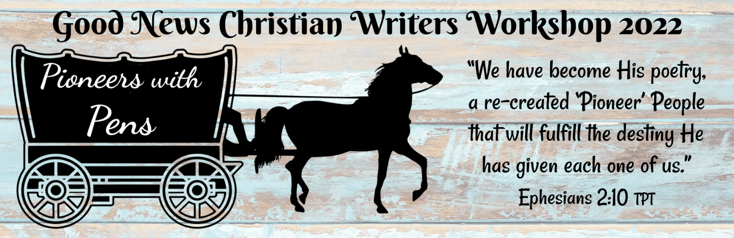
Name:____________________________________________________________________
Address:__________________________________________________________________
City/State/Zip:_____________________________________________________________
Phone:______________________Email:________________________________________

Genre(s) of writing you are interested in:
_____Picture Books _____Devotionals
_____Elementary Chapter Books _____Blogging
_____Middle School Reads _____Magazine Articles
_____Young Adult _____Playwriting
_____School/Church Curriculum _____Screenwriting
_____ Journaling _____Fiction
_____Non-Fiction _____Short Story
_____Biography _____Poetry
_____Memoir _____Bulletins/Newsletters
Skill Level: _____ Idea/Notes only _____ 1st Draft _____ Full Manuscript
_____ Published _____ Unpublished

List any food allergies or special dietary needs:______________________________
______________________________________________________________________

Payment: $55 Includes 6 sessions, continental breakfast, and luncheon.
$45 Early Bird Discount—Registration by May 2.
Cash or checks payable to Pageant Wagon Productions LLC and snail-mail c/o Kathryn Ross, 1791 Kings Road, Vineland, NJ 08361
Credit Cards Accepted: Pay online at www.pageantwagonpublishing.com/good-news-workshops

Cash _______ Check #_________ CC ________ Online ______ Date Recv’d ____________

If this is a financial hardship contact us for SCHOLARSHIP information.

