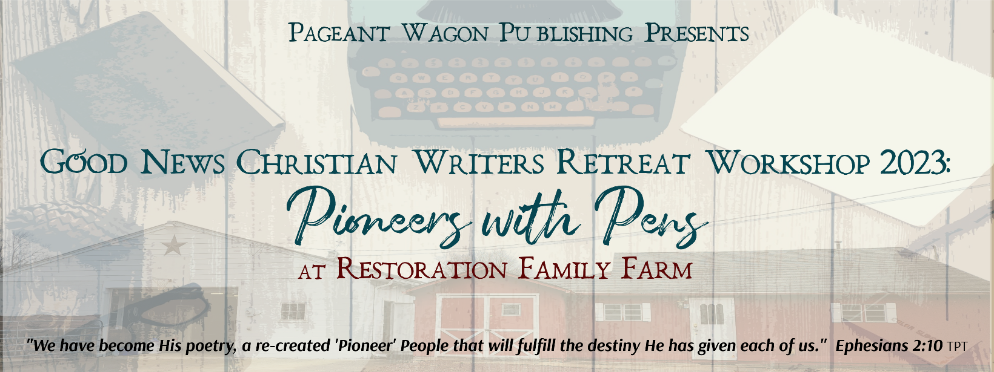
Name:____________________________________________________________________
Address:__________________________________________________________________
City/State/Zip:_____________________________________________________________
Phone:______________________Email:________________________________________

Genre(s) of writing you are interested in:
_____Picture Books _____Devotionals
_____Elementary Chapter Books _____Blogging
_____Middle School Reads _____Magazine Articles
_____Young Adult _____Playwriting
_____School/Church Curriculum _____Screenwriting
_____Journaling _____Fiction
_____Non-Fiction _____Short Story
_____Biography _____Poetry
_____Memoir _____Bulletins/Newsletters
Skill Level: _____ Idea/Notes only _____ 1st Draft _____ Full Manuscript
_____ Published _____ Unpublished

PAYMENT: $120 Includes all main sessions, breakout groups, supplies, activities, continental breakfast, snacks, and beverage bar, on October 27-28, 2023.
For Check payment, add $7.95 TAX. Online Pay Portal adds it automatically.
A separate Love Offering will be taken to cover Restoration Family Farm fees and hospitality.
NOTE: Friday/Saturday Lunches and Friday Dinner will be paid separately. The Chuck Wagon Menu and Pay Portal Order Options will be available mid-summer. All Early Bird Registered Attendees will receive email notification when the Chuck Wagon and Pay Portal is open online! Expected costs are $12 lunch, $15 dinner.
TOTAL DUE $____________

Cash or checks payable to Pageant Wagon Productions LLC and snail-mail c/o Kathryn Ross,
1791 Kings Road, Vineland, NJ 08361 or call 856 205-9334
Credit Cards Accepted: Pay Portal at pageantwagonpublishing.com/store/c2/pageant-wagon-bookshop

Cash _______ Check #_________ CC ________ Pay Portal ______ Date Recv’d ____________

